**2022** **"ShuWei** **Cup"**

**Letter** **of** **Commitment**

We have carefully read the《Regulations of the 2022 "ShuWei Cup" IMCM》(The 2022 revision, hereinafter referred to as the "Contest Regulations", which can be downloaded from the official website).

We are fully aware that after the start of the competition, team members are not allowed to communicate or discuss with anyone outside the team (including instructors) in any way, including telephone, E-mail, Tieba, QQ group, WeChat group, etc. Whether actively participating in the discussion or passively receiving the discussion information is a serious violation of competition discipline.

And we are fully aware that copying the results of others is a violation of the rules and regulations of the competition. If we need to cite others' achievements or materials (including online materials), we must list them according to the description of the reference and mark them in the text.

**We** **make** **a** **solemn** **commitment** **to** **the** **reputation** **and** **integrity** **of** **college students,** **strictly** **abide** **by** **the** **rules** **and** **regulations** **of** **the** **competition,** **in** **order** **to ensure** **the** **fair** **and** **equitable** **of** **the** **competition.** **Any** **violation** **of** **the** **rules** **and regulations** **of** **the** **competition** **will** **be** **dealt** **with** **seriously.**

We authorize the organizing committee of the 2022“ShuWei Cup” to make our papers available for public display in any form (including online publication, formal or informal publication in books, journals and other media).

Problem chosen (A/B/C/D): C

Team number(13 digit uniform numbering): 2022092412600

School(Full name): **Chengdu University of Information Technolog**y

Team member(Handwriting signature):1：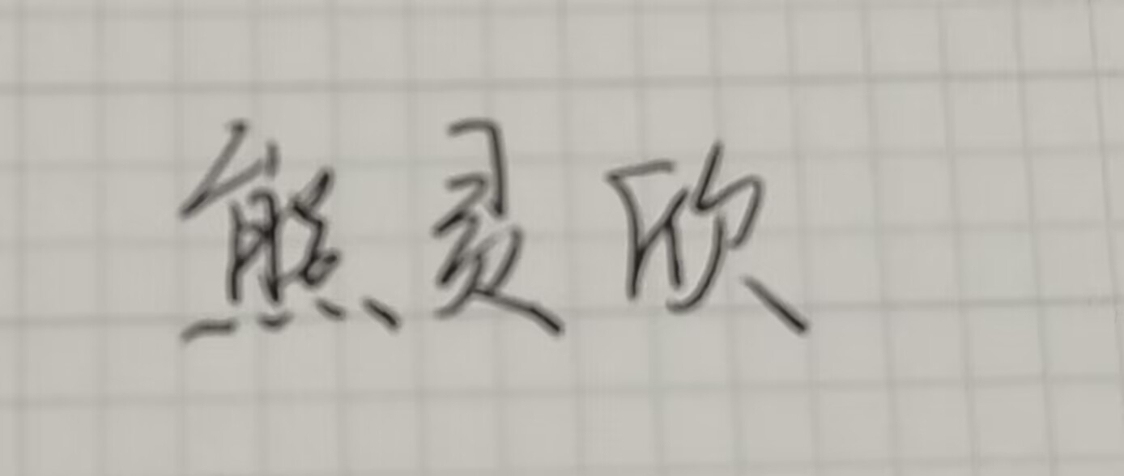

2：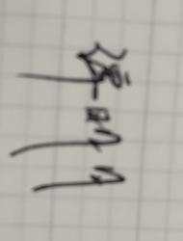

3：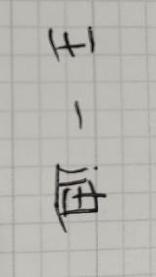

Date: 2022.11.20